PHASE 4
Testing Document

Invigilation Processor – Examiner’s Magnifier

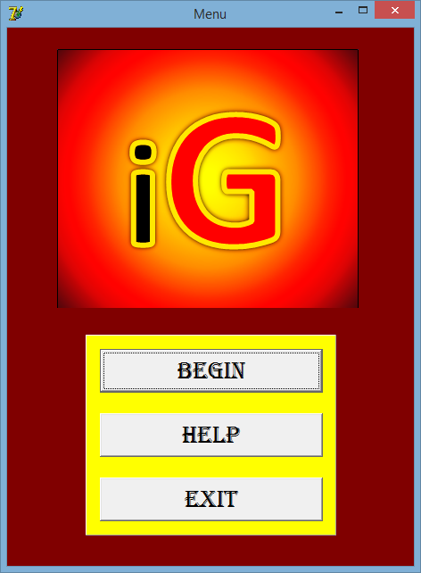

Developed by Tony Guo

Signoffs
Phase | Teacher | Date | Signature
4) Testing document | Mrs. Niebuhr

Fulfillment of features:
≪Copy all your features from the Specification document in and tick of whether your program can or cannot do it≫
Feature | Yes | No | Mostly

Specifications of Program Functions
- Get all the input of the excel files.
- Extract all the data and puts all the data into classes.
- Summaries the data.
- Gives a platform where all the invigilators can be seen and tools can be used to make the schedule.

Specifications of User Interface
- Input interface where users can input data manually or load a file.
- Output interface where all final input data is displayed.
- Help interface to display help for each form.
- Summary interface to display the summarized info.
- Splash screen to look professional.
- Front page to access the input and help.

Specifications of Help
- Help on each screen/form with richedits.
- Guidelines on the interface to guide users on what to do.
- Pop-up messages to guide user and for ease of access.
- Lots of defensive programming and show messages.

Specifications of Data Storage
All data is stored in the Input Folder and are mostly excel files:
- Staff Pictures 2015 folder
- Exam June 2015
- Extra Time Kids Note.txt
- Extra Time Learners 2015.txt
- Important Dates 2015.xlsx
- Staff 2015.xlsx
- Subjects 2015.xlsx
- Totals for Subjects 2015.xlsx
One file will be stored in Output Folder:
- Log.txt

Testing data:
Description of what is tested | Testing data | Results
If program can input all files that are to be inputted. | All excel files in Input Folder. | All files were able to be inputted – their paths were shown.
If all the data was retrieved and are accurate. | The inputted files followed by pop up messages and displays. | All results from input were shown and showmessages were shown.
Proceed only proceeds when everything is done. | btnSpeedButton Done click. | All boxes on menu went green.
Summary is different and seems accurate all the time. | Different invigilators and number of gr 8 and 9 learners. | Values were different everytime and an average matric invigilator does a third less than a normal invigilator.
Frames of invigilators are all present. | From staff list added different amount of invigilators the whole time. | Each time the number of frames created was equal to the number of invigilators there were.
Random Roll works. | Added invigilated hours. | A random teacher was given the whole time.
All info was shown on date. | Different dates were selected. | All the info was there.
All subject teachers were there that were selected in input. | Different teachers were selected for different subjects in input. | Exact same teachers were shown for the selected subject as it was on input. Perfect.
Log.txt works. | Adding different teachers and session exam papers to write to file. | All the added text was there in Log.txt.

